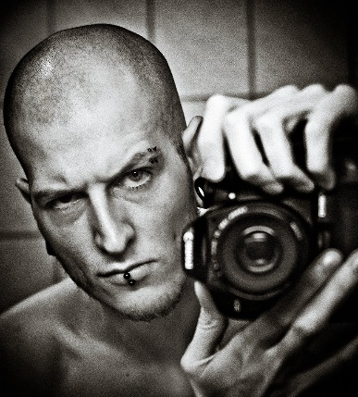
Rebecca Thomas
Mobile: 0400 123 456
Email: rt@cv.com.au
With extensive experience within the Health, Medical & Pharma industry and a proven diligent and reliable team member, I believe I am an asset to any company.

Education | Edith Cowan University (from Mar 89 to Dec 91)  Completed Diploma of Health Science at the Edith Cowan University.
Experience | Sir Charles Gairdner Hospital (from Apr 01 to Apr 01)  - I have been working in the Short Stay Unit in the role of Registered Nurse for the past 8 and half years. My role not only includes patient care, but I am also required to work regularly as shift coordinator. This role involves allocating staff their patient load, coordinating admissions from both the emergency department and operating theatres, as well as being a resource to more junior and less experienced staff members.  Sir Charles Gairdner Hospital (from Apr 99 to Apr 01)  - During my time working as a casual nurse, I was required to work in many different wards in the hospital. Not only did this experience increase my nursing skills, I also had to become very flexible as I often did not know where I would be working until I arrived at work.
Skills | - ITIL  - Microsoft Access  - Microsoft Office 2007  - Advanced Wound Management  - Training
Hobbies | - Sales And Promotion  - Reading  - Cricket  - Gaining New Skills  - Social Media
References | - Name: Rick Thompson  Position:Senior Partner  Company: Resume Template Pty Ltd  Phone: 02 9000 1111


Important Copyright Notice: This document is the sole property of ResumeTemplate.com.au. You are licensed to use this document for strictly personal use only. It may not be copied or redistributed in any way without prior consent from ResumeTemplate.com.au.
Remove this box before utilising for personal use.

